Worksheet 09

**Cloud Nine**

# AJAX, jQuery, PHP practices

1. Download *C273_L09CloudNine.zip* from LEO. Save and extract it to C:\xampp\htdocs\C273_L09CloudNine\.
2. Start NetBeans. Create a PHP Project with Existing Source that points to above folder.
3. Start the XAMPP Control Panel, and **start both the Apache and MySQL component**.
4. Type <http://localhost/phpmyadmin> on your browser to open PHPMyAdmin.
5. Create database **c273_p09**. Import the file **c273_p09.sql** into that database. You should have the table **statistics** under the database.
6. **TODO**: Create a PHP webservice called **getStatistics.php** which retrieve all records from the statistics table and encode in JSON message.

Test the webservice using the URL

<http://localhost/C273_L09CloudNine/getStatistics.php>

You should get the following JSON message:

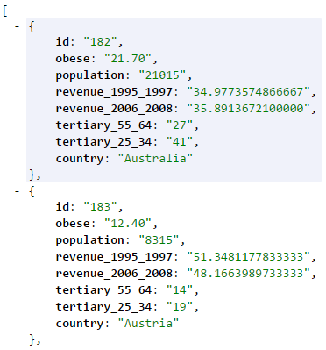

1. **TODO**: Create a PHP webservice **getCountryDetails.php** which retrieve all columns from the statistics table based on the id and encoded in JSON message.

Test the webservice using the URL <http://localhost/C273_L09CloudNine/getCountryDetails.php?id=186>

You should get the following JSON message:

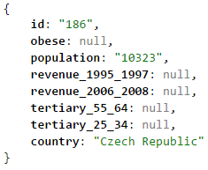

1. **TODO**: Write the jQuery code in **showCountryObese.js** in the js/ folder to make an AJAX call to **getCountryDetails.php** . Open **showCountryObese.php** to include showCountryObese.js to produce an output like below.

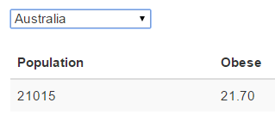

1. Open showWorldPopulation.js in the js/ folder. The code given initializes the ChartJS plugin which you have learnt in the past.

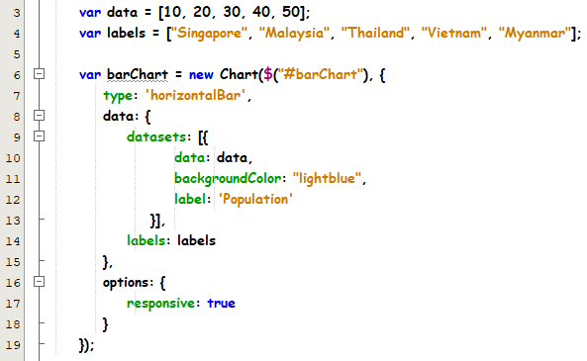

Lines 3-4 – Initialize data and labels arrays for the chart

Lines 6-7 – Initializes the Chart object. In order to display a horizontal bar chart, the "type" attribute is initialized to ‘horizontalBar’

1. Run showWorldPopulation.html and you should get the output like below:

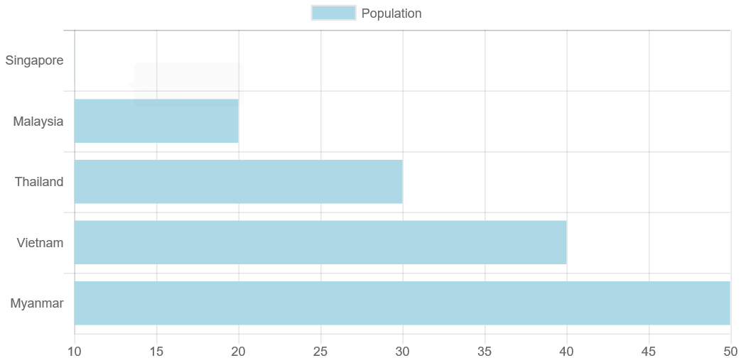

1. **TODO**: Modify the jquery code in showWorldPopulation.js to make an ajax call to getStatistics.php to retrieve the population data for all countries and display an output like below. Hint: You need to populate the data and labels array with the “population” and “country” values from the JSON response.

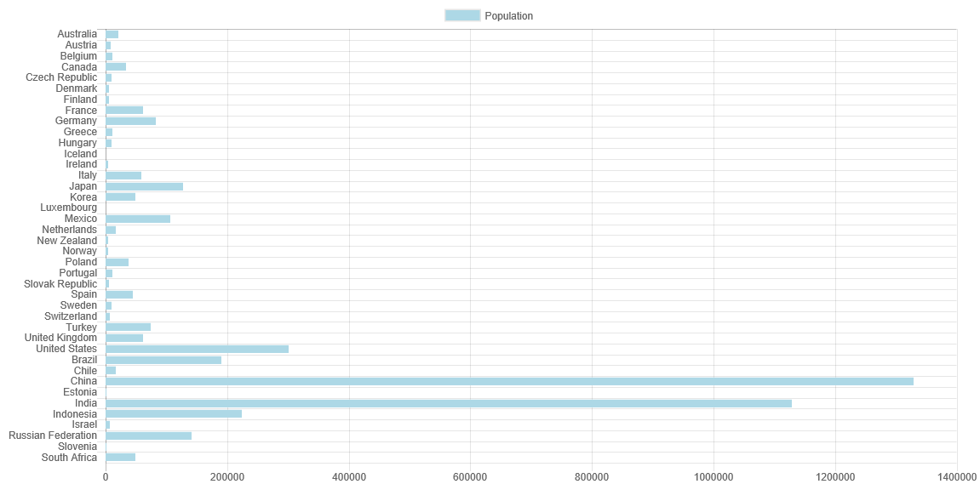

1. Follow the Azure Guide in LEO to deploy the project to the cloud.

# What is Cloud Computing?

1. Find out 3 advantages and disadvantages of cloud computing.

**Resources**: “Cloud Computing Best Animation” (video on LEO)

<https://cloudacademy.com/blog/disadvantages-of-cloud-computing/>

1. There are 3 service models of cloud: i) SaaS ii) PaaS iii) IaaS. List the key attributes of each model and give examples of each service models. You can search for ‘Cloud Fundamentals’ on LinkedIn Learning <https://www.linkedin.com/learning/>
2. Overview of Microsoft Azure is available at YouTube <https://youtu.be/3Arj5zlUPG4>